NETWORK TOPOLOGIES

Q1. Draw and label diagrams of star, bus, and mesh network topologies on paper or using any drawing tool. For each, write one real-world app or service (like WhatsApp, Flipkart, or IPL streaming) that could use that topology and explain why in 1-2 lines.
Ans.
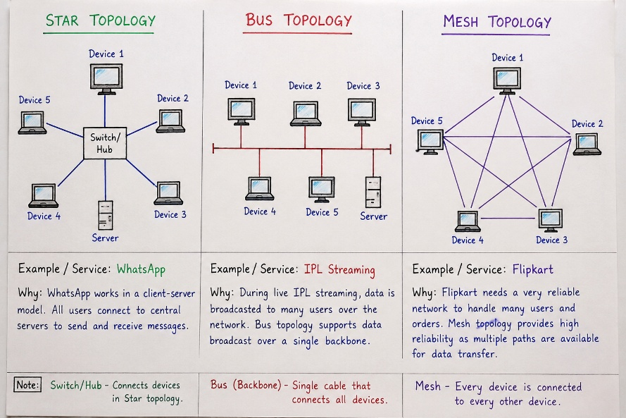
1. Star Topology – WhatsApp
WhatsApp can be compared to a star topology because users connect to central servers to send and receive messages.
2. Bus Topology – IPL Streaming
In a bus topology, many devices share one main communication line. It is similar to sending the same live-stream data to many users.
3. Mesh Topology – Flipkart
Mesh topology has multiple paths between devices. This can help large services like Flipkart keep the network reliable even if one path fails.
NOTE:-
- Switch/HUB – Connects device in a Star topology
- Bus (Backbone) – Single cable that connects all devices.
- Mesh – Every device is connected to every other device.

Q2. Create a comparison table listing at least four pros and four cons for each of these topologies: star, bus, ring, mesh. Include a column for 'Best Use Case' and give an example from apps you use (e.g., Instagram, Zomato, Paytm).
Ans.
Topology | Pros | Cons | Best Use Case | Example App/Service
Star | 1. Easy to set up  2. Easy to find problems  3. One device failure does not affect others  4. Fast and reliable | 1. Needs more cables  2. Costs more  3. Depends on a central switch  4. If the switch fails, the network stops | Homes, schools, offices | Instagram – users connect through central servers to send and receive data.
Bus | 1. Simple design  2. Uses less cable  3. Cheap  4. Good for small networks | 1. Main cable failure stops the network  2. Can become slow  3. Hard to find problems  4. Not good for many devices | Small networks | IPL Streaming – similar data is sent to many users from one main source.
Ring | 1. Data moves in order  2. Fewer data collisions  3. Every device gets a chance  4. Works well with steady traffic | 1. One failure can affect the network  2. Hard to add devices  3. Hard to repair  4. Can become slow | Networks needing orderly data flow | Paytm – can be compared to ordered transaction processing where data moves through controlled network paths.
Mesh | 1. Very reliable  2. Has many paths for data  3. One path failure does not stop the network  4. Good performance | 1. Expensive  2. Needs many connections  3. Hard to set up  4. Hard to manage | Large and important networks | Zomato – its services need reliable connections between servers to handle orders, payments, and delivery information.

Q3. Imagine you are designing a new multiplayer mobile game like PUBG or Free Fire. Choose a suitable network topology for the game servers and justify your choice in 3-4 lines, mentioning how it would impact speed, reliability, and cost.
Ans. I would choose a Mesh Topology for the game servers. It provides high speed and reliability because data can travel through different paths. If one connection fails, the game can still continue using another path.
However, it is more expensive because it needs more connections and equipment.
Q4. Given this scenario: A small Flipkart-style warehouse wants to connect 8 computers for order processing and inventory updates. Recommend a network topology, sketch a quick diagram, and explain your reasoning in 2-3 lines. Hint: Consider factors like cost, ease of troubleshooting, and future expansion.
Ans. I would recommend a Star Topology.
Reason: It is easy to set up and troubleshoot because all 8 computers connect to one central switch. It is also easy to add more computers later, and the cost is reasonable for a small warehouse.
